TJA, 8. razred
petek, 22. 5. 2020 (24. šolska ura dela na daljavo)
Zdravo, kako ste kaj? Šolsko leto se bliža koncu, bo šlo? Do sedaj vam je šlo odlično. Malo še!
Danes vas čaka ena ura angleščine. Čim prej se lotite dela, da vam bo ostalo veliko časa za druge stvari.

Ne pozabite nam svojega dela poslati do petka,
22. maja 2020.

Sledite spodnjim navodilom. Vaje rešujte v zvezek ali kar v ta dokument. Če potrebujete pomoč pri tem, sporočite.
Reading comprehension
Making people aware
(Student's book, page 60)

1 Read and listen to the text. Answer the questions.

Making people aware

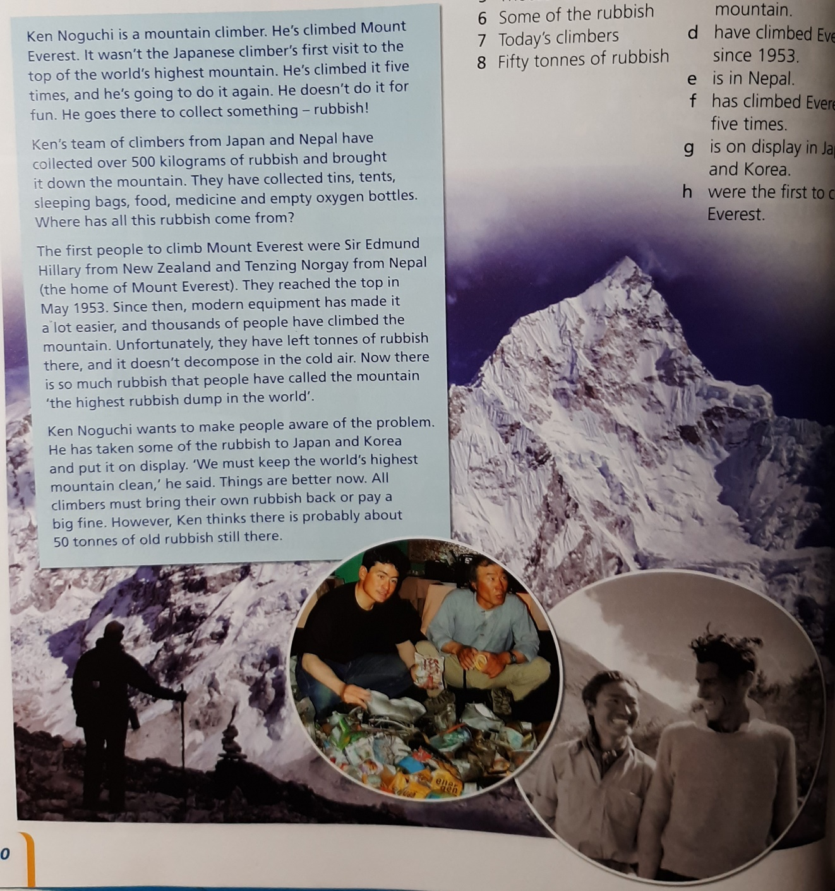

- Who is the text about? Kliknite ali tapnite tukaj, če želite vnesti besedilo.
- Where is he from? Kliknite ali tapnite tukaj, če želite vnesti besedilo.
- What is 'the world's highest rubbish dump'? Kliknite ali tapnite tukaj, če želite vnesti besedilo.
- Has the problem improved? Kliknite ali tapnite tukaj, če želite vnesti besedilo.

2 Choose the correct endings.
- Ken Noguchi Izberite element.
- Mount Everest Izberite element.
- Ken's team Izberite element.
- Hillary and Tenzing Izberite element.
- Thousands of people Izberite element.
- Some of the rubbish Izberite element.
- Today's climbers Izberite element.
- Fifty tonnes of rubbish Izberite element.

3 Answer the questions.
- What kind of things have people left on the mountain? Kliknite ali tapnite tukaj, če želite vnesti besedilo.
- Why is it easier for modern climbers to climb Everest? Kliknite ali tapnite tukaj, če želite vnesti besedilo.
- Why is there so much rubbish on the mountain? Kliknite ali tapnite tukaj, če želite vnesti besedilo.
- Whay has Ken Noguchi taken some of the rubbish to Japan and Korea? Kliknite ali tapnite tukaj, če želite vnesti besedilo.
- What happens now if climbers leave their rubbish behind? Kliknite ali tapnite tukaj, če želite vnesti besedilo.

REŠITVE
1
- Ken Noguchi
- Japan (He's a Japanese climber.)
- Mount Everest (People have called the mountain 'the highest rubbish dump in the world'.)
- Yes (Things are better now.)

2
- f
- e
- b
- h
- d
- g
- a
- c

3
- tins, tents, sleeping bags, food, medicine, empty oxygen bottles
- Because of modern equipment.
- Because a lot of people have climbed the mountain and they have left rubbish there.
- To make people aware of the problem.
- They pay a big fine.

